vrijdag 13 mei 2016
13:57
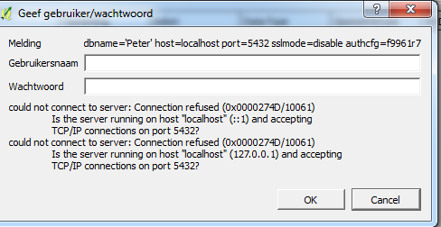

13-5-2016 13:57 – Schermopname

You need a username and password to get access to the PostgreSQL-DB. Creating it did not succeed.

