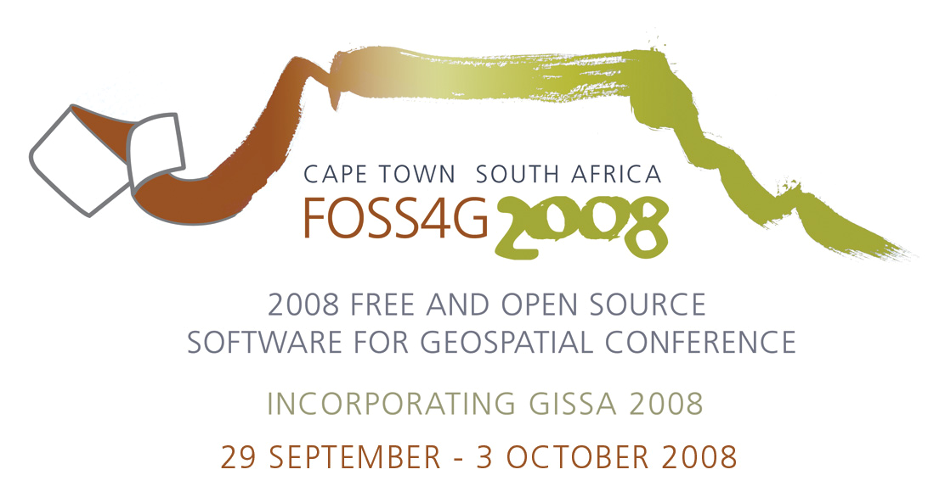

13 May 2008
FOSS4G 2008 Call for Papers – Extension of Abstract Submission Date to Friday, 23 May 2008
We are pleased to announce an extension in the abstract submission deadline for the 2008 Free and Open Source Software for Geospatial (FOSS4G) conference, incorporating GISSA 2008, being held from 29 September to 3 October, in beautiful Cape Town, South Africa. This is due to the fact that there was a glitch with the online submission process which appeared to be already closed for submissions yesterday, the 12 of May on the last day of submissions. Thank you to those of you who informed us, so that we could rectify the problem. I apologize for the inconvenience caused. As a result we have extended the date for the submissions of abstracts to Friday the 23rd of May 2008. Please endeavor to submit your abstract as soon as possible. We believe that we have ironed out the glitch in the system. In summary the following still applies:
Academic Track
This year we are thrilled to host the first academic track for peer reviewed papers at FOSS4G. The date for submission of abstracts to the academic track is now 23 May 2008. Abstracts have to be 500-600 words in length, please ensure that these are long enough as abstracts which are too short will automatically be disregarded. These will be reviewed by the Program Committee of the academic track of FOSS4G 2008. You will be notified of acceptance or otherwise on or before 17 June. If your abstract is accepted for the academic track, you have to submit a full paper by 18 August 2008 for inclusion in the proceedings. The Programme Committee will compile a short list of high quality papers addressing substantial research questions. Authors of these papers will be invited to submit a revised paper in response to reviewer comments and suggestions for inclusion in the South African Computer Journal.
Presentation Track
The date of submission for abstracts of 500-600 words to the presentation track is now the 23 May 2008. The abstracts submitted to this track will be chosen by an open community process. You will be notified of acceptance or otherwise on or before 17 June. If your abstract is accepted for the presentation track then you will be required to submit your presentation by 18 August 2008 for inclusion in the CD proceedings.
Poster Track
Due to the demand for posters we have included a poster track to the conference. Should you wish to display a poster at the conference, please submit a short abstract of no more than 150 - 300 words detailing the topic and content of your proposed poster. Please also indicate the poster size in the abstract (poster sizes are limited to an A1 or AO size). The deadline for the poster abstract submission is Monday the 30 of June 2008. Posters will be selected as space is limited. You will be notified of acceptance or otherwise on or before the 21 of July 2008.
Important Dates
 | Presentations | Peer reviewed papers for the academic track
Submission of abstracts | 12 May 2008 has been extended to 23 May 2008
Notification of acceptance | 17 June 2008
Submission of papers / presentations | 18 August 2008 | 18 August 2008
Submission of abstracts for posters | 30 June 2008 | N/A
Notification of acceptance of poster | 21 July 2008 | N/A
FOSS4G2008 Conference | 29 September – 3 October 2008

Submission Process
In order to submit an abstract please visit the www.foss4g2008.org website, and select Proposal Submission. This will take you to a login page, where you can enter your existing account information, or if you are new to the site, register for a user account before you can proceed. You will then be taken through a step by step process to submit your abstract. Please make sure that you select the correct track option.
NOTE: To submit an abstract you will need to be logged in as an Author: From the User Home page, under Roles, select Authors. If you do not have a role of Author available then go to the “my profile” link and check the Author checkbox. You will then have an Author role under the User Home page.
General Information
All FOSS4G 2008 papers/presentations take the form of 25 minute talks, with 5 minute question and answer sessions at the end. Anyone can submit a presentation or paper and take part in the conference as a presenter. Posters will be on display for the duration of the conference. Designated poster sessions are scheduled to take place on 30 September and 1 October 2008 between 12:00 and 13:00
Author guidelines for the formatting of the paper or presentation are available online on the conference website.
Please note that your paper or presentation will only be included in the proceedings once your registration to the conference has been received in full.
For more information, see the FOSS4G 2008 site: http://www.foss4g2008.org

Should you have any further queries that are not addressed on the website then please contact the following:
Technical Programme & submissions: Inge Netterberg [inge.netterberg@gmail.com]
Academic Track: Serena Coetzee [scoetzee@cs.up.ac.za]
General Track: Inge Netterberg [inge.netterberg@gmail.com]
Poster Track: Mandy Vickers [mandyv@mintek.co.za]

Kind regards,
Inge Netterberg
Technical Programme coordinator
FOSS4G 2008

