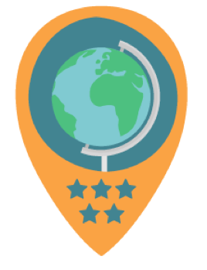

10 Questions to ask while you’re making your GeoBadge

- Who will be the primary Point of Contact for the badge?

Someone in your organization will have to serve as the primary contact for your GeoBadges. This is the person that the team at the American Geographical Society will work with. If there is transition in the primary contact, your organization will need to designate a new person or, or deactivate their badges.

2. Will you describe your GeoBadge as a “skill” or “service” badge?

The text you enter in your “Description” field will appear in the Explore page. Each GeoBadge tends to recognize a skill an individual has achieved, or an act of service an individual has undertaken. So, your description will be something like “I can make an edit in OpenStreetMap” or “I have dedicated 50 hours to a crisis mapping deployment.”

3. Will you require evidence?

When making your GeoBadge you’ll have the option to either “require evidence” or not. If you do not require evidence, earners will simply request to earn your GeoBadge, but not provide any evidence of work they’ve done. If you require evidence, you will have to specify what evidence you are looking for - such as a URL link to an example of student work.

4. Will you require approval? And who will you allow to approve?

If you do not “require approval” for your GeoBadge, earners will earn your GeoBadge automatically upon request.

5. Does the earner need to have any prior skills to earn this badge?

For example, are there pre-requisites badges that need to be earned prior to undertaking this badge? Are there other external requirements that the earner needs to have prior to undertaking this badge? As you’re creating the Lesson for your badge, you’ll want to think about whether or not the earner will need any prior skills, credentials, or experiences before they are eligible to tackle your badge. This information can be detailed in the “Minimum Requirements” field.

6. When requests come in, how will you manage the review of evidence?

You should take some time to think about the actual social process by which you will handle GeoBadge submissions. Have you discussed roles and responsibilities with colleagues? Have you thought about how you will evaluate evidence and determine who should earn your geobadge?

7. If personnel changes, how will you deal with transition your badges?

If you or colleagues with responsibility for managing a GeoBadge move on from their job, you’ll either need to change the contact names on the badge, or deactivate it so that it does not appear on the Explore page. If you want to delete the GeoBadge altogether, contact the GeoBadges administrator.

8. Do you have permission to share all the content you use in your description and information?

In the process of creating your GeoBadge lesson you may use images, videos or text. Before publishing your GeoBadge you should make sure that you have permission to use all of this content, whether that’s because you own the content, or because it has an open license that permits its use. Ultimately, issuing organizations are responsible for the content associated with their GeoBadges.

9. Do you want to print off anything physical to hand out to those who earn your badges?

A digital badge is great, but you may want to have something physical to hand out to your earners - such as a sticker or patch. To make this happen, you can download the GeoBadge icon image and print off something yourself.

10. How will you share and promote your badges?

GeoBadges will not attract learners unless you take a proactive approach to doing communications and outreach. As part of your GeoBadges plan, you should think about how you can generate interest and excitement, perhaps through events, blog writing, etc.

