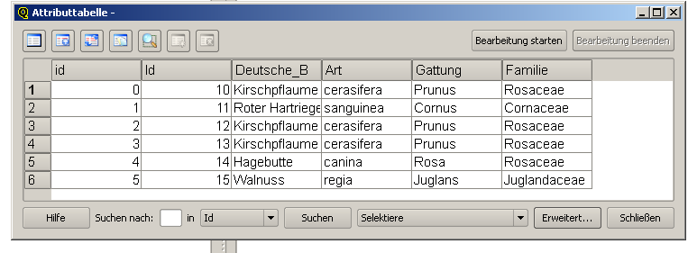

http://localhost/cgi-bin/mapserv.exe?map=C:/TestDaten/Map_Dateien/Test_Baeume.map&REQUEST=getFeature&Typename=Test_Baeume&Version=1.0.0&service=WFS&filter=

<ogc:Filter+xmlns:ogc='http://ogc.org'+xmlns:gml='http://www.opengis.net/gml'><ogc:PropertyIsLike+wildCard='*'+singleChar='.'+escape='!'><ogc:PropertyName>Deutsche_B</ogc:PropertyName><ogc:Literal>*Hagebutte*</ogc:Literal></ogc:PropertyIsLike></ogc:Filter>

