FOSS4G 2006
September 12 – 15, 2006
Swiss Federal Institue of Technology & University of Lausanne
Lausanne, Switzerland
Booth #
nver Convention Center, Denver Colorado, Booth 1328

GENERAL INFORMATION

Event Overview: FOSS 4G is a four day conference, bringing together the Free and Open Source Software for Geoinformatics (FOSS4G) communities. The conference incorporates the OSGIS Conference, Mapserver User Meeting (MUM), GRASS Users Conference, Java oriented FOSS4G and EOGeo Workshops.

The conference focuses on an array of open source technologies and presents how they are being used around the world. Seminars and workshops will share the theme of advancing open source GIS technology, by covering management and technical aspects as well as the latest trends.

Finally, with the recent creation of the Open Source Geospatial Foundation, FOSS4G2006 will be an exciting opportunity to network with foundation members and projects.

Show Dates: July 24-28, 2006
Location: Swiss Federal Institute of Technology (EPFL)
1015 Lausanne, SWITZERLAND
+41 21 693 11 11

AND

University of Lausanne (UNIL)
CH-1015 Lausanne, SWITZERLAND
+41 21 692 11 11

Audience Profile: This conference is an exciting opportunity for both users and managers to network, learn about products and services, and develop both technical and management skills for adopting open source technologies. The event is expected to draw over 500 people from around the globe, representing the existing user and developer communities as well as those interested from government, non-government organisations, academia, and industry.

Expected Attendance: 500

Autodesk Event Lead: Tina Mena, Sr. Event Manager, World Wide Sales
415-259-8517 cell

Autodesk ISD Brand Lead: Kirsten Davidson, Autodesk ISD Brand Manager

OSGeo Lead: Arnulf Christi, OSGeo

On-Site Show Management: TBA.

For more information: http://www.foss4g2006.org/conferenceDisplay.py?confId=1

Exhibit Show Hours: Wednesday, July 26 10:00 AM – 5:00 PM & 6:00 PM – 7:30 PM (Reception)
Thursday, July 27 10:00 AM – 5:00 PM
Note: Although there will be concurrent sessions on Thursday, show management expect a lot of exhibit hall only traffic.

Hotel Accommodations: Please refer to this url for a list of recommended confernce hotels. http://www.foss4g2006.org/internalPage.py?pageId=4&confId=1

OBJECTIVES

Objectives:
- Raise awareness for OSGeo through speaker sessions and booth traffic
- Demonstrate MapGuide
- Increase press awareness of OSGeo

SCHEDULE OF EVENTS: AT-A-GLANCE

Tuesday, 12 September
08:00 | Registration
09:00 – 18:15 | Workshop Sessions #1
Wednesday, 13 September
09:00 – 10:30 | Welcome and Opening Plenary
10:30 – 11:00 | Break
11:00 – 13:00 | Conferences
13:00 – 14:00 | Lunch
14:00 – 18:15 | Workshop Sessions #2
Thursday, 14 September
09:00 – 11:00 | Conferences
11:00 – 11:20 | Break
11:20 – 13:00 | Conferences
13:00 – 14:00 | Lunch
14:00 – 16:00 | Conferences
16:00 – Midnight | Main Social Event – Paddle Steamer Cruise
Friday, 15 September
09:00 – 11:00 | Conferences
11:00 – 11:20 | Break
11:20 – 13:00 | Conferences
13:00 – 14:00 | Lunch
14:00 – 16:00 | Closing Conference Plenary

BOOTH/DEMO INFORMATION

Exhibit Move-in
Hours: Monday, September 11 08:00 – 17:00 PM

Exhibit Move-out
Hours: Friday, September 15 16:00 -

Booth Properties: We plan to use the same booth properties as the picture below, however, it will be branded OSGeo. Final rendering to follow.

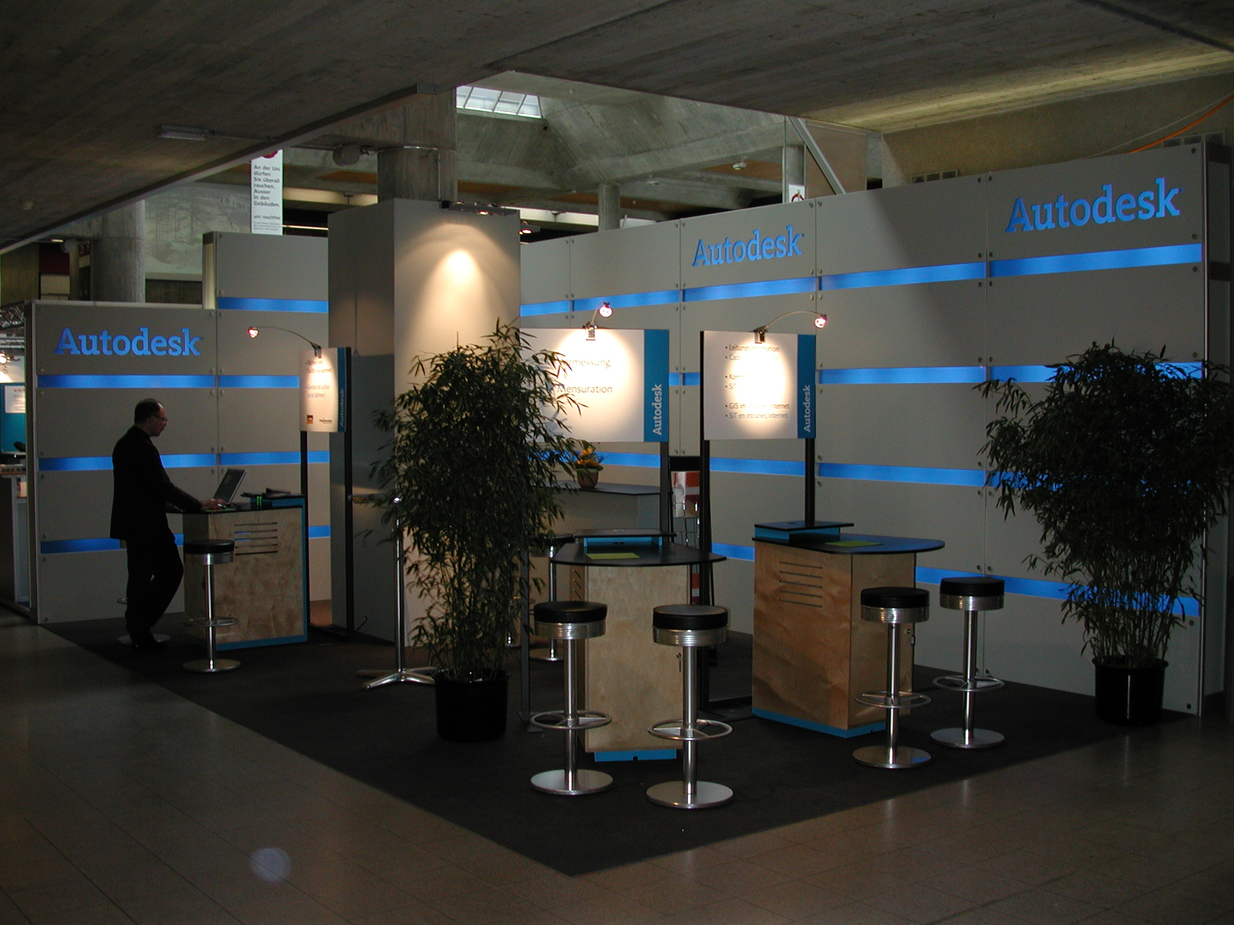

Shipping: TBA

Staff Schedule

 | Monday, 9/11 | Tuesday, 9/12 | Wednesday, 9/13 | Thursday, 9/14 | Friday, 9/15
TBD

WORKSHOPS / ABSTRACTS

WORKSHOPS:
Presenter: Robert Bray, Autodesk; Paul Spencer, DM Solutions Group; Zak James, DM Solutions Group
Title of Presentation: MapGuide Open Source Users Workshop
Date/Time: Tuesday, 12 September, 09:00 – 13:00
Location: TBD
Abstract:. The goal of this workshop is to present the new MapGuide Open Source. Topics will include installation, configuration, using the Site Administrator, using Studio Open Source to create and manage layers and maps, and some coverage of developing applications based on MapGuide Open Source using the development APIs.

Presenter: Robert Bray, Autodesk
Title of Presentation: Advanced MapGuide Open Source Development
Date/Time: Tuesday, 12 September, 14:00 – 18:15
Location: TBD
Abstract:. The goal of this workshop is to show how to use the MapGuide APIs to develop web mapping applications and geospatial web services. Topics will include serving live data to Google Earth, performing geo-spatial analysis, digitizing and shared
markup, and using the resource database to create maps dynamically.

All development will be done in PHP using the latest release

Presenter: Arnulf Christl, CCGIS
Title of Presentation: Mapbender Workshop
Date/Time: Tuesday, 12 September, 14:00 – 18:15
Location: TBD
Abstract:.

KEYNOTE:
Presenter: Gary Lang
Title of Presentation: TBD
Date/Time: TBD
Location: TBD
Abstract:. TBD

MARKETING COMMUNICATIONS

Platinum Sponsorship:

Promotional
- Mention in opening plenary
- Place for 4 prominent banners throughout all prime areas of conference
- Prominent display of organization name and logo on conference passes
- Prominent display of organization name and logo on cover of program
- Prominent display of organization name and logo in promotion and advertisements
- Recognition on the Conference website as a Platinum Sponsor including your company logo with hotlink to your website
- One page Literature insert in all the conference programs and related kits
- and/or tailored offering according to price

Event
- Conference Keynote address
- Official title sponsor of conference
- If organized, official Sponsor of a night event (downtown Lausanne)

Passes and Booth Space
- 4 conference passes (workshop only as observators)
- One 8mx4m exhibition booth space in a high traffic area

Merchandising
- Option to supply Conference Promotional Gift

Booth Space
- Clear floor space incl. general hall lighting and heating, daily cleaning of the aisles and surroundings and final cleaning.
- Internet connections : wired connections for Exclusive, Platinum and Gold sponsorship levels, WiFi connections for silver and bronze sponsorship levels
- power connections
- table and chairs (2 tables and 4 chairs for platinum sponsorship level, 1 table and 2 chairs for other sponsorship levels)

Promotional Material
All promotional material such as banners, flyers, tent cards, promotion gift, etc. should be provided by the sponsor.

Lanyard:
- Autodesk to sponsor lanyards?

Collateral:
- (100) OSGeo Overview Brochure
- (75) OSGeo Education Brochure
- (75) OSGeo GDAL Brochure
- (75) OSGeo Geodata Brochure
- (75) OSGeo Geotools Brochure
- (75) OSGeo Grass Brochure
- (75) OSGeo Mapbender Brochure
- (75) OSGeo MapBuilder Brochure
- (75) OSGeo MapGuide Brochure
- (75) OSGeo MapServer Brochure

ADDITIONAL INFORMATION:

Registration/Badges:

4 Conference Passes:
1. TBD
2. TBD
3. TBD
4. TBD

Team Contact List:
Staff | Title, Company | Email | Office/Cell phone number
Arnulf Christl | Consultant, CCGIS GbR | arnulf.christl@ccgis.de | +49 228 90826 23
Chiara Bogo | ISD Marketing Manager, Autodesk | Chiara.bogo@autodesk.com | +39 02575511
Kirsten Davidson | ISD Brand Manager, Autodesk | Kirsten.davidson@autodesk.com
Lisa Landers | Marketing Consultant, Autodesk | Lisa.landers@autodesk.com | 415-507-8182 /
Michaela Schneeberger | AE ISD Central Europe, Autodesk | Michaela.schneeberger@autodesk.com | +49 89 547 69 347
Peter Rummel | Marketing Solution Manager, Autodesk | Peter.rummel@autodesk.com | +49 89 54769 238 / +49 176 208201119
Peter Ter Haar | EMEA ISD, Autodesk | Peter.haar@autodesk.com | +31-180-691000
Sean Sternfeldt | Sr. Product Manager, MapGuide, Autodesk | Sean.sternfeldt@autodesk.com
Tina Mena | Sr. Event Manager, Autodesk | Tina.mena@autodesk.com | 415-507-6241 / 415-259-8517

