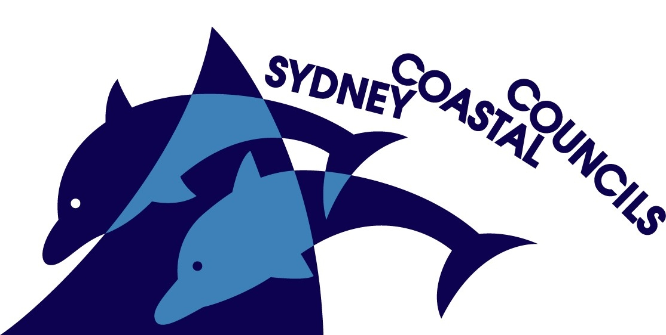
SYDNEY COASTAL COUNCILS GROUP Inc.
C/- City of Sydney Council
Level 14, 456 Kent Street
GPO Box 1591, SYDNEY NSW 2001
Phone: (02) 9246 7791
Facsimile: (02) 9265 9660
Internet: www.sydneycoastalcouncils.com.au
ABN: 39 638 876 538

PRESS RELEASE
FOR IMMEDIATE RELEASE: 7:00 A.M. EST, November 2, 2009

GIS. Helping Councils model tomorrow, today!

Everyone needs help modelling the future and determining the implications for tomorrow for the management decisions made today.

The ‘Sydney’s Integrated Spatial Future’ event being presented by the Sydney Coastal Councils Group (SSCG) and the Surveying & Spatial Sciences Institute (SSSI) aims to demystify Geographic Information Systems (GIS) for all local government staff.

A level of uncertainty and caution is experienced presently by some asset managers, planners and environmental staff when integrating and communicating to other disciplines.

A ‘wall of mystery’ can also exist between the information requested and the formats, data sets and databases required when communicating graphical and geographical data across various departments and organisations.

“Participation and quality communication amongst spatial developers, interpreters and the decision-makers is an integral part of addressing the issues and concerns coming from the use of spatial information by local government”, said SCCG Chairperson, Clr. Wendy McMurdo. “With this forum the SCCG is aiming to provide the necessary information and discussions to enable opportunities to enhance the integration of information across the Sydney region and the spatial industry”, she added

“The event is inspired by themes such as risk and hazard assessment, asset management and decision support, with a focus of bringing together key industry experts with local government management and practitioners.”, concluded Clr. Wendy McMurdo.

Event Details:

The details of the Forum are as follows:
Event: SCCG & SSSI GIS Forum: Sydney’s Integrated Spatial Future
Location: Customs House, Barnet Long Room, 31 Alfred St, Circular Quay, Sydney
Date: Wednesday 9 December 2009
Doors Open: 9:00am
Time: 9:30am to 5pm
Web: www.sydneycoastalcouncils.com.au/Events.htm

Media opportunity:
Organisers & Speakers will be available for interview, on the day @ Customs House, The Barnet Long room, 31 Alfred St, Circular Quay, Sydney, 2001 Wednesday 9 December 2009 from 9:00am to 5:00pm.

Media Contact:
Mr. Geoff Withycombe, SCCG, Executive Officer, (e) geoff@sydneycoastalcouncils.com.au (p) +61 2 9246 7791
Clr. Wendy McMurdo, SCCG, Chairperson, (e) wmcmurdo@hornsby.nsw.gov.au (m) 0438 777 518

