Global Consultation on the role of UNGGIM Private Sector Network strengthening the UN Integrated Geospatial Information Framework (IGIF)

Context
The United Nations Committee of Experts on Global Geospatial Information Management (UN-GGIM) was established in 2011 to enhance Geospatial information management, support decision-making, and contribute to sustainable development. UN-GGIM supports Member States and aspires to address global challenges related to Geospatial information, notably to implement the 2030 Agenda for Sustainable Development and other development objectives.
Recognizing the critical need for effective geospatial information management to deliver the 2030 Agenda, UN-GGIM adopted the Integrated Geospatial Information Framework (IGIF) in August 2018. This integrated framework provides a basis and guides countries to develop and strengthen their geospatial information management arrangements and related infrastructures. The framework guides collecting, managing, analyzing, and disseminating geospatial information to support evidence-based decision-making and sustainable development.
The IGIF provides a common language and framework for geospatial information management, helping countries to develop and implement national strategies and policies. Anchored by nine Strategic Pathways, the framework is a mechanism for articulating and demonstrating leadership in Geospatial information and the capacity to take positive steps.
The IGIF is anchored and implemented through three (3) critical areas of influence: governance, technology, and people. These strategic pathways aim to help governments implement integrated geospatial information systems to achieve a vision for sustainable social, economic, and environmental growth.
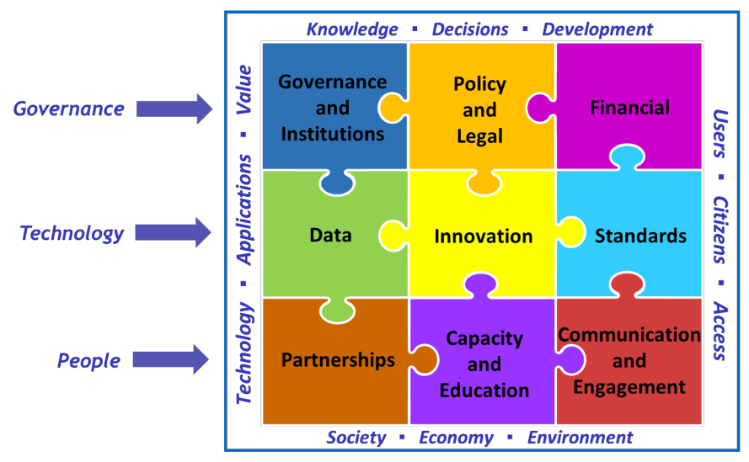
Figure 1: UN-IGIF is anchored in nine strategic pathways

About the Global Consultation
The United Nations Committee of Experts on Global Geospatial Information Management (UN-GGIM) has officially endorsed the creation of the UN-GGIM: Private Sector Network (UN-GGIM: PSN). This decision comes in recognition of the need for stronger partnerships between the public and private sectors to fully leverage new data sources and technologies, in order to achieve the United Nations' 2030 Agenda.
The UN-GGIM: PSN is collaborating with the UN-GGIM to implement the Integrated Geospatial Information Framework (IGIF) in countries as a means of enhancing geospatial information management. This will enable countries to effectively support their developmental agendas and achieve their national goals.
UN-GGIM: PSN is conducting global consultations with relevant public, private, and academic stakeholders in order to understand how the geospatial private sector can support the implementation of the IGIF in their unique contexts and countries. The global consultations will be held in all the regions as follows:
- Americas (21 May 2024 10 am EST)
- Africa (23 May 2024)
- Asia Pacific (24 May 2024 3:30 pm AEST)
- Europe (Date TBD)
- Middle East (Date TBD)

Format of Discussions
Each regional consultation will last for two hours and will be led by the UN-GGIM Regional Chair of the Private Sector Network. A mentimeter-based survey will be conducted during the session, interspersed with discussions.

Why is it important to be a part of the consultation process
For the Private Sector: As a member of the UN-GGIM: Private Sector Network, it is in our best interest to share the knowledge of improving the processes related to the collection, management, sharing, and use of geospatial information in strengthening the UN-GGIM Global Agenda. The private sector, by supporting the implementation of the UN-IGIF in respective countries, can ensure deeper collaboration and partnerships with the government, users, and academic institutions, wherever required. We can also expect global geospatial information to grow exponentially as we establish better processes, raise awareness, and create value through best practices.
For the Public Sector: As geospatial data custodians and/or users, it is important for us to establish mutually beneficial relationships with the private and the academic community in order to ensure that geospatial information is sufficiently available and usable for achieving national and international goals. This consultation will provide a medium to express your expectations from the private sector and understand their perspective.
For the Academia: Geospatial information and technology advancements rely heavily on research and education. As a key stakeholder in the implementation of the IGIF, you will have the opportunity to support research, education and capacity building initiatives and to share your concerns and expectations with the community to enhance IGIF implementation in your country’s context.

Registration Link
To register for the global consultation in your region, fill out the Google form -
https://forms.gle/5LpUZmq9u4rfriNS7

Contact
For more details on the consultation, please contact your regional UN-GGIM:PSN Chair or write to megha.datta@woolpert.com

Discussion Questions

Governance and Institutions
- How can the private sector contribute to governance and institutional arrangements in strengthening IGIF implementation?

Policy and Legal
- Policies in your country support ease of doing business for the geospatial sector:
  - Yes, we have sufficient and well-rounded policies for the purpose.
  - We have some good policies, but there are loopholes and practical hinderances in achieving ease of doing business in our country.
  - No, we don’t have sufficient policies for ease of doing business.
- What kinds of policies are required to enhance the role of the Private sector in achieving the goals of the IGIF?
- Are there sufficient laws to promote shared funding or public-private partnerships of geospatial/infrastructure projects in your country?
  - Yes
  - No
  - There are a few, but more is needed

Finance
- Chose the issue you foresee with a shared funding model (public-private partnership) for capturing/maintaining/disseminating foundational geospatial data in your country:
  - The private sector doesn’t have the capital to invest in projects or to take the financial risk involved in a PPP.
  - Regulatory and legal policies in the country don’t support PPP.
  - There is a lack of trust between government entities and the private sector for a successful PPP.
  - We fear political instability that may disrupt the PPP projects' future.
  - There are not enough lucrative PPP opportunities in the country.
  - Any other
- What PPP engagement model will you be most open to working on?
  - Geospatial data collection partnerships
  - Management of spatial assets
  - Collaboration for utility service delivery
  - Property or Land Registry Partnerships
  - Setting up a CORS network or any other Geospatial
  - Any other
- In what way would your organization be willing to participate in the socio-economic impact assessment of investing in geospatial information?
  - Conduct a socio-economic impact assessment of geospatial information independently.
  - Help the national mapping agency build a methodology and scope.
  - Share the survey with relevant stakeholders.
  - Sponsor a grant for the survey to the national mapping agency.
  - We will not participate.
  - Any other, please specify.

Data
- Rate the level of data available in your country for the 14 fundamental data themes:
  - Global Geodetic Reference Frame
  - Addresses
  - Buildings and Settlements
  - Elevation and Depth
  - Functional Areas
  - Geographical Names
  - Geology and Soils
  - Land Cover and Land Use
  - Land Parcels
  - Physical Infrastructure
  - Population Distribution
  - Orthoimagery
  - Transport Network
  - Water
- What productivity improvement measures do you suggest for better collection, processing, maintenance, and dissemination for the national mapping agency in your country?

Innovation
- How would your company be willing to support the promotion of innovation in the Geospatial Sector in your country?
  - Become an active member of an Innovation Group
  - Help with conducting technology needs assessments
  - Building innovation programs and hubs
  - Provide data/content for the innovation hubs.
  - Provide training and workshops.
  - Provide platform or cloud services to the innovators/start-ups.
  - Sponsor funds for the innovation hubs.
  - Be a part of the review board/process.

Standards
- What initiatives are undertaken for Standards development in your country?
  - Participating in the process of standards development
  - Developing specifications for the category of data/products they offer
  - Popularizing the available standards through communication channels and mandates for partners
  - Participating in national needs assessment for standards
  - Developing and participating in a community of practice
  - Developing capacity and training on various standards
  - Adopting national standards for products and services

Partnerships
- What forms of partnerships are common in the Geospatial information sector in your country?
  - Cross-sector or interdisciplinary initiatives
  - Industry-Academic collaborations for joint research and development
  - Community partnerships with civil society
  - International trade or business
  - Standards development
  - Awareness building initiatives
  - Co-funding of building fundamental data themes
  - Capacity building
  - Other forms of partnerships
- What partnerships do you seek for the Geospatial sector in the country?

Capacity and Education
- Are there orientation/training programs on IGIF available in your country?
- The private sector can support capacity-building initiatives in the following ways:
  - Providing training to government officials on the latest technologies and products.
  - Providing skill development courses to students and young professionals to promote Geospatial education.
  - Undertake a skill gap analysis in the country regarding geospatial education.
  - Developing a community of practitioners.
  - Establishing and contributing to innovation hubs.

Community and Engagement
- What efforts are taken for Geospatial advocacy to the users promoting geospatial information without a motive to sell a product or service?
  - Organizing periodic conferences/meetings.
  - Publishing geospatial knowledge content that promotes knowledge exchange.
  - Establishing an industry association that acts as a collective voice for the geospatial industry in the country.
  - Building and participation in various stakeholder engagement programs.
  - Collaboration for research and development.
  - Any other, please specify.

