LIMA CONVENTION CENTER

FACT SHEET

Measuring 262,500 square feet, the building stands ten floors tall and will position Peru as a top destination for international events.

Location: District of San Borja, very close to the District of San Isidro (financial center) and the District of Miraflores (tourist and cultural center) where most international chain hotels are located.

Area: 262,500 sq. feet Capacity: 9,950 people
10 floors and 5 levels (single and double height)

18 conference rooms that can be divided into 22.

Opening: October 12, 2015 for the Annual Meeting of the Boards of Governors of the World Bank and the International Monetary Fund.

2 restaurants
945 parking spaces distributed in 4 levels.
It allows 10,000 simultaneous Wi-Fi connections.
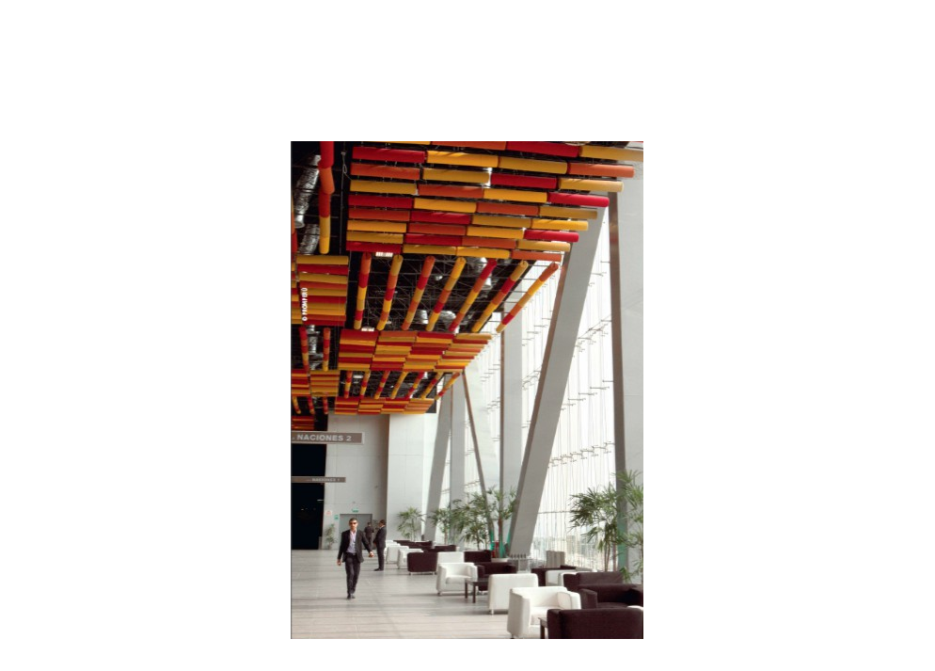
The air conditioning system will provide each conference room with temperatures that are independently adjustable.

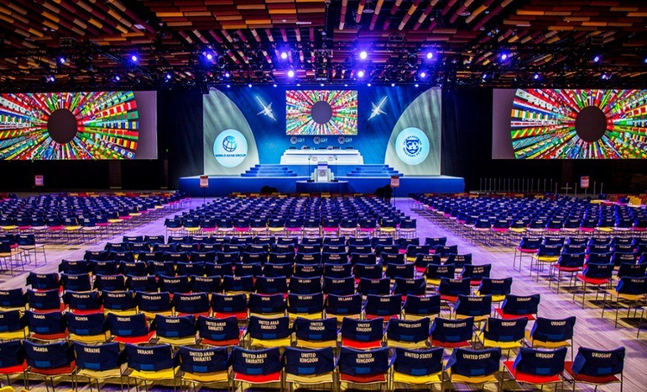

It has been designed considering efficiency, acoustic and visual comfort. It also features green areas in four of the five levels, waiting rooms for all conference rooms, a commercial area and a tourist services area. The Convention Center includes 14 elevators and 25 escalators.

The Convention Center has a high-tech lighting system. The communications system (audio, video and data) uses last generation connectivity equipment, and wireless coverage prepared for 10,000 simultaneous connections. The video conferencing and telepresence system allows interaction among participants and speakers from different parts of the world. Simultaneous translation booths are included in all rooms.

The Annual Meeting of the World Bank Group and the International Monetary
Fund

The Lima Convention Center opened in October 2015 when more than 12,000 officials from 188 countries gathered in Lima for the Annual Meeting of the World Bank Group and the International Monetary Fund.

The meeting brought together central bankers, ministers of finance and development, private sector executives, academics, and representatives from the civil society. The Annual Meeting took place in Latin America again after 48 years when it was held in Rio de Janeiro back in 1967.

Among the attendees were Christine Lagarde, Managing Director of the IMF; Jim Yong Kim, President of the World Bank; Nobel Prize Joseph Stiglitz; and actor and social activist Sean Penn.

The event was a great opportunity for several country groups such as the Group of Twenty (G-20), the Group of Twenty-Four (G-24), and other organized groups to hold bilateral and ministerial meetings. Many financial institutions around the world had the opportunity to meet in Lima so that the capital of Peru became the center of the world economy for a week.

All this meant an unprecedented opportunity for Peru to attract investment, strengthen the business climate, network with private international companies, and transfer knowledge to the academic community.

The organization of the Annual Meeting of the World Bank Group and the International Monetary Fund was possible thanks to the outstanding performance of the Peruvian economy in the last decade that strengthens Peru's commitment to innovation, human capital development, and increasing investment to promote sustainable development. “This meeting is also a recognition for all Peruvians, their ventures, their investments, their work and their ambitions, and the responsible management of the economy", said Peru Minister of Economy, Mr. Alonso Segura.

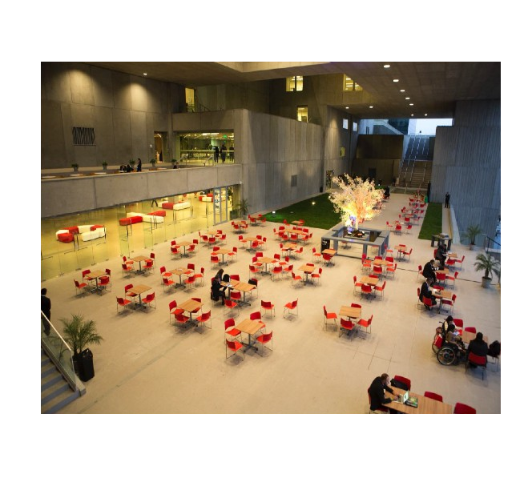
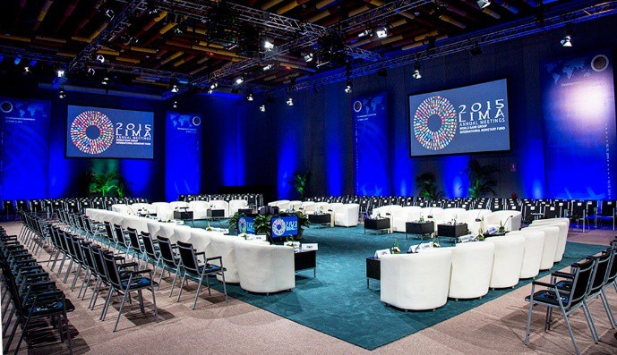

Past events:

- First Asia-Pacific Economic Cooperation (APEC) Senior Officials’ Meeting.
- 7th World Conference of the Extractive Industries Transparency Initiative - EITI
- 4th Latin American Sanitation Conference - LATINOSAN
- 4th World Congress of Biosphere and 28th Session of the Man and the Biosphere Programme International Co-ordinating Council (UNESCO)
- 2016 “Peru Moda” Fashion Trade Show
- 2nd UNWTO World Forum on Gastronomy Tourism
- 10th International Congress on Oral Rehabilitation
- 9th APEC Tourism Ministerial Meeting

Upcoming events:

- APEC Women and Economy Forum
- Third APEC Senior Officials’ Meeting and Related Meetings (SOM3)
- APEC SME 020 FORUM III
- APEC Education Ministerial Meeting
- APEC Senior Finance Officials’ Meeting (Drafting Session)
- APEC Finance and Central Bank Deputies Meeting
- APEC Finance Ministerial Meeting
- 4° ABAC (APEC Business Advisory Council) Meeting
- APEC Voices of the Future
- APEC CEO SUMMIT
- APEC Economic Leaders´ Meeting (AELM)”

LIMA CONVENTION CENTER MEETING ROOMS CAPACITY

MEETING ROOMS  LIMA CONVENTION CENTER |  | AREA Sq ft | CAPACITY | HEIGHT  ft
Level 1 | Sala San Borja 1 | 9,452.96 | 600 | 25.10
 | Sala San Borja 2 | 9,454.69 | 600 | 25.10
 | Sala Lima 1 | 7,190.07 | 420 | 25.10
 | Sala Lima 2 | 10,786.72 | 780 | 25.10
Level 4 | Sala Puruchuco | 7,406.53 | 500 | 9.19
 | Sala El Paraiso | 3,075.57 | 200 | 9.19
 | Sala Manchay | 4,555.71 | 300 | 9.19
 | Sala Armatambo | 2,482.16 | 150 | 9.19
 | Sala Maranga | 1,561.63 | 100 | 9.19
 | Sala Mateo Salado | 4,866.14 | 300 | 9.19
 | Sala Huallamarca | 7,713.41 | 500 | 9.19
 | Sala Cajamarquilla | 3,299.14 | 200 | 9.19
Level 6 | Sala Pachacamac | 7,922.66 | 500 | 9.19
 | Sala Huantille 1 | 1,936.96 | 100 | 9.19
 | Sala Huantille 2 | 2,430.70 | 150 | 9.19
 | Sala Mangomarca | 4,384.67 | 300 | 9.19
 | Sala Pucllana | 8,461.07 | 500 | 9.19
Level 5 | Sala Ichma 1 | 1,660.98 | 100 | 9.19
 | Sala Ichma 2 | 2,388.29 | 150 | 9.19
Level 8 | Sala de las Naciones 1 | 56,128.24 | 3500 | 29.10
 | Sala de las Naciones 2
 | Sala de las Naciones 3

