Dear colleagues,
The steps needed to derive TC coefficients for multispectral image are not completely uniform.
Here is the description of algorithms I’m going to follow for derivation of custom TC coefficients.

The first recipe
(Suggested by Jackson, 1983 and Liu et al., 2015)

- Detection of ‘soil line’
We manually choose the pixels corresponded to bare soils with various features related to moisture, soil type etc. using ground-based research data.
It would be better to see that points on bivariate scatterplots in spectral n-space. I know the option of creating of such plots exist in Grass, though joining to the recent question I also need to ask if it is possible to analyze them (at least visualize the chosen pixels and obtain something like this – Fig1).
Another way is image classification, though it is also unclear for me if I can see the pixels corresponded to soil class on similar scatterplots?

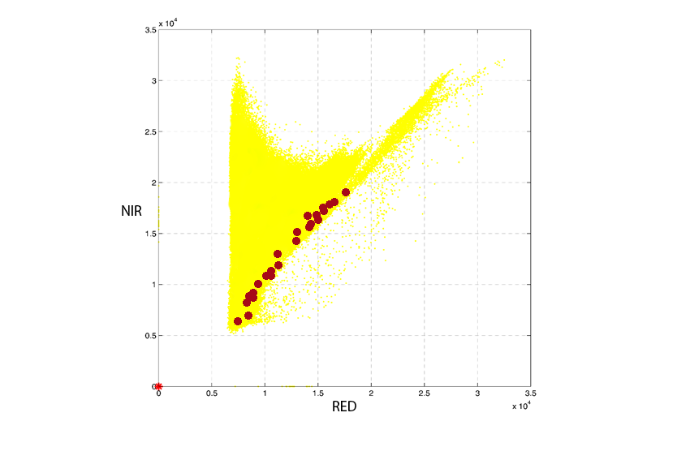
Fig1. Marked bare soil pixels on bivariate NIR/RED scattergram

The second step is creating the soil line itself (or to be more precise the ‘plane of soils’) by say, linear regression (Fig2).
Fig. 2. ‘Soil line’ derived from bare soil pixel samples determined in accordance to ground based data

- Calculation:
Then the algorithm suggested by Jackson, (1983) can be applied:

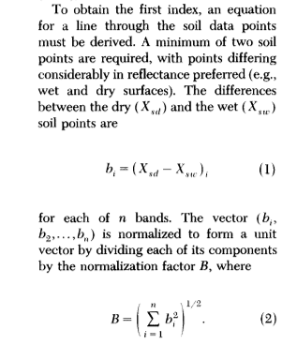
Such a way coordinates of the unit vector A are desirable coefficients for custom TCT Brightness for each band.

After that we find the points (pixels) of green vegetation (Fig3)

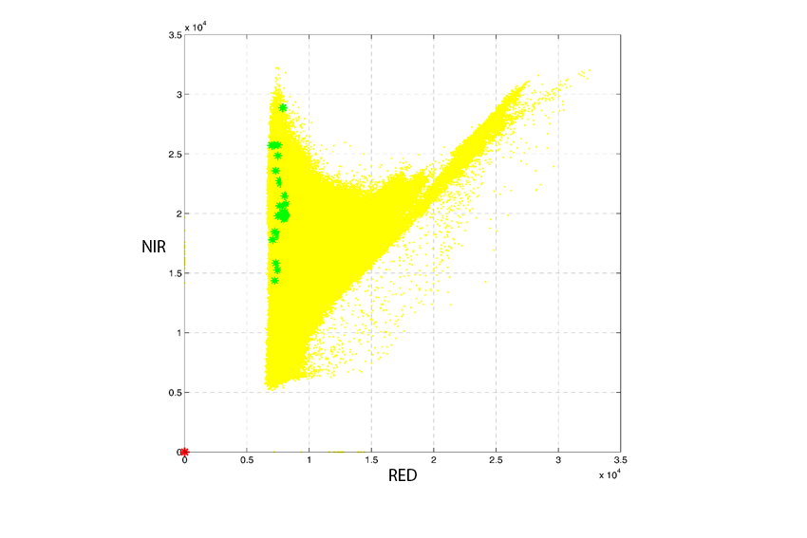
Fig3. Vegetation pixel samples determined in accordance to ground based data

…And follow the steps below:

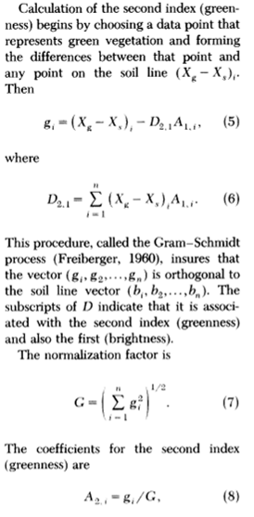

Then we must take into account that Jackson couldn’t describe feature Wetness as only Landsat MSS data were available in 1983.
So the 3rd feature in OLI data is wetness, but not yellowness as Jackson suggested. Nevertheless, it can be calculated the same way:

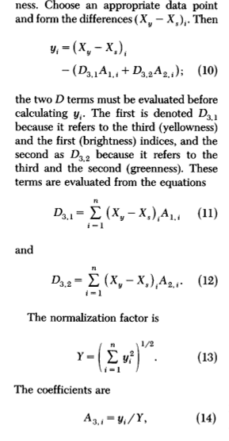

I’m planning to stop with wetness.

There is also another algorithm suggested by Lobster, Cohen, 2007 and Baig et al., 2014
I’ll describe it a little bit later

