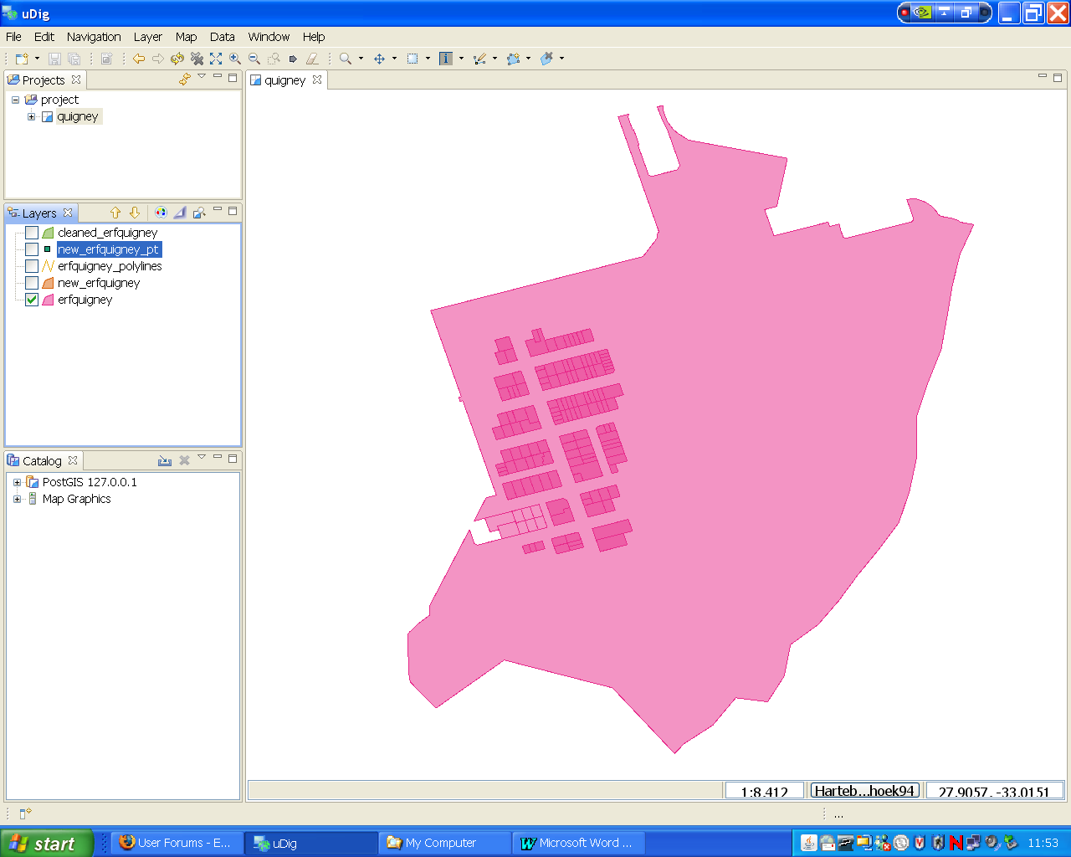
Postgis polygon (erfquigney ) imported from a shapefile
1

BIG POLYGON

SMALL POLYGONS within Big POLYGON, these are not touching the boundary of the BIG POLYGON

POLYGONS outside the BIG POLYGON
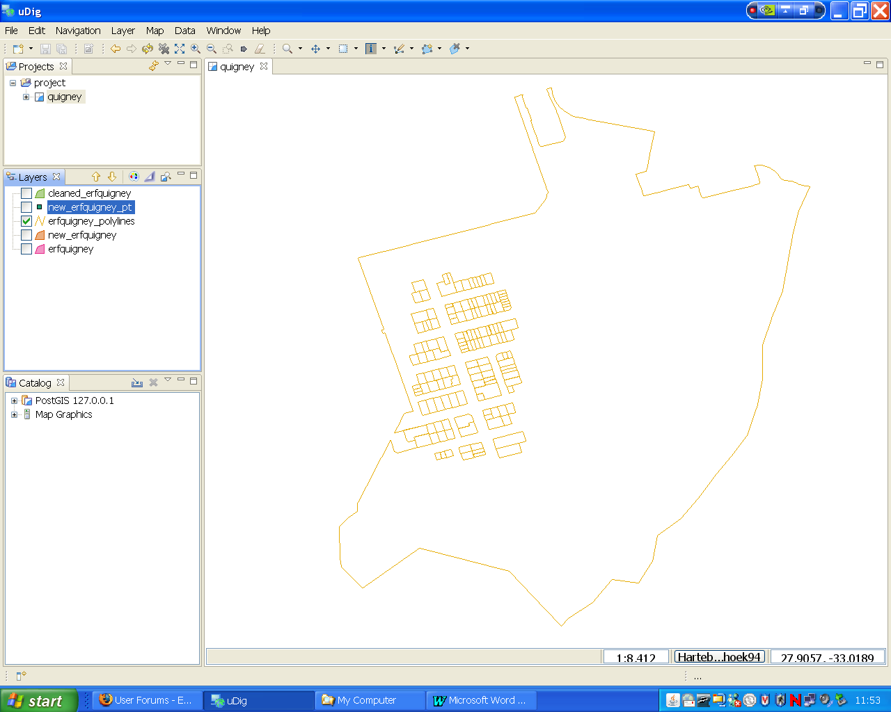

Create a polyline from a polygon
I used the statement below
2
CREATE TABLE erfquigney_polylines AS
SELECT ST_Boundary(the_geom) AS the_geom
FROM erfquigney;

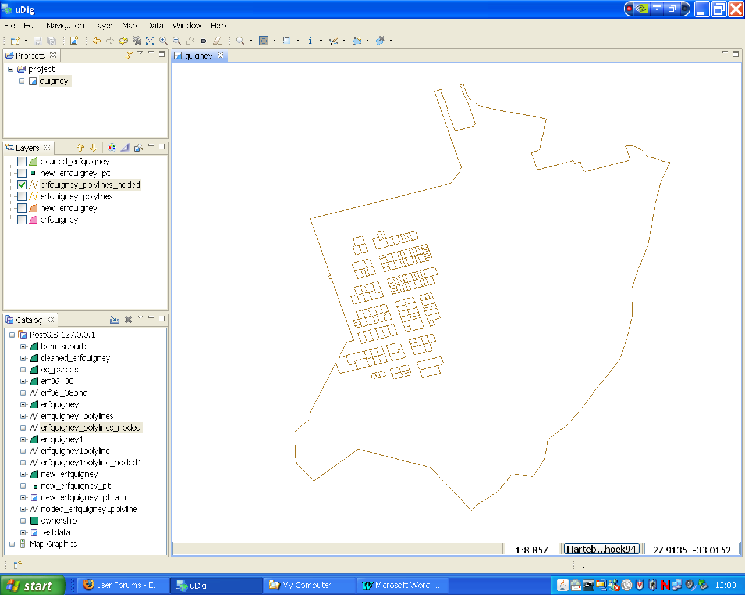
Create a noded polyline
I used the statement below
3
CREATE TABLE erfquigney_polylines_noded AS
SELECT ST_Union(the_geom) AS the_geom
FROM erfquigney_polylines;

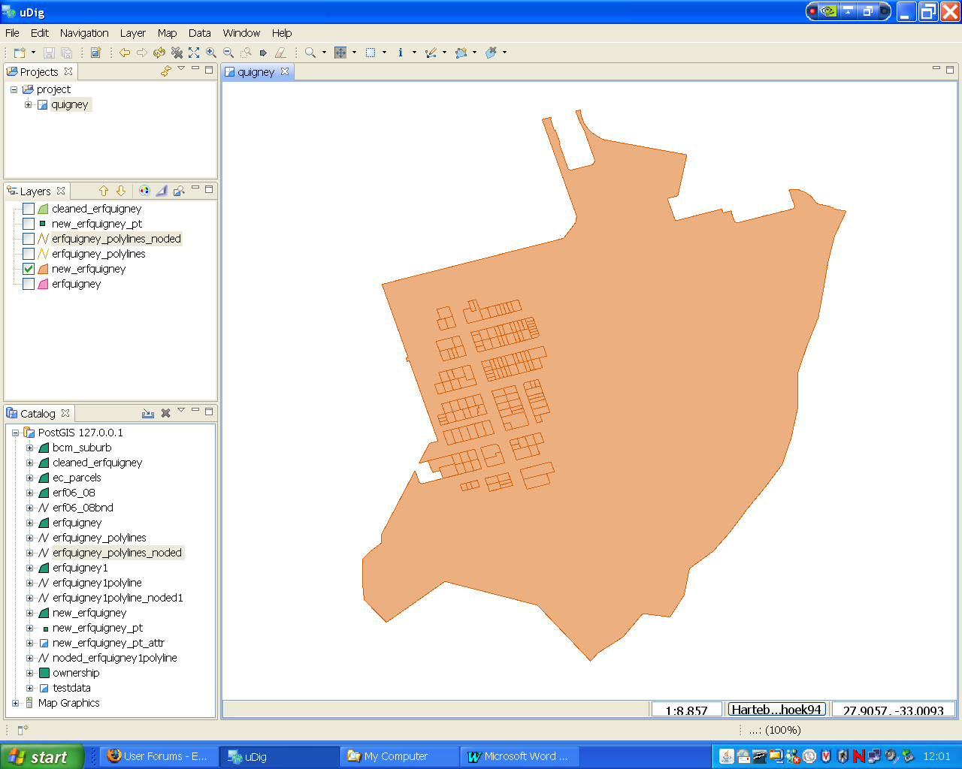
Recreate polygon from noded polyline

4
CREATE TABLE new_erfquigney(id serial PRIMARY KEY, the_geom geometry);
INSERT INTO new_erfquigney(the_geom)
SELECT geom AS the_geom
FROM ST_Dump((
SELECT ST_Polygonize(the_geom) AS the_geom
FROM erfquigney_polylines_noded));

Create a point feature of above repolygonized feature

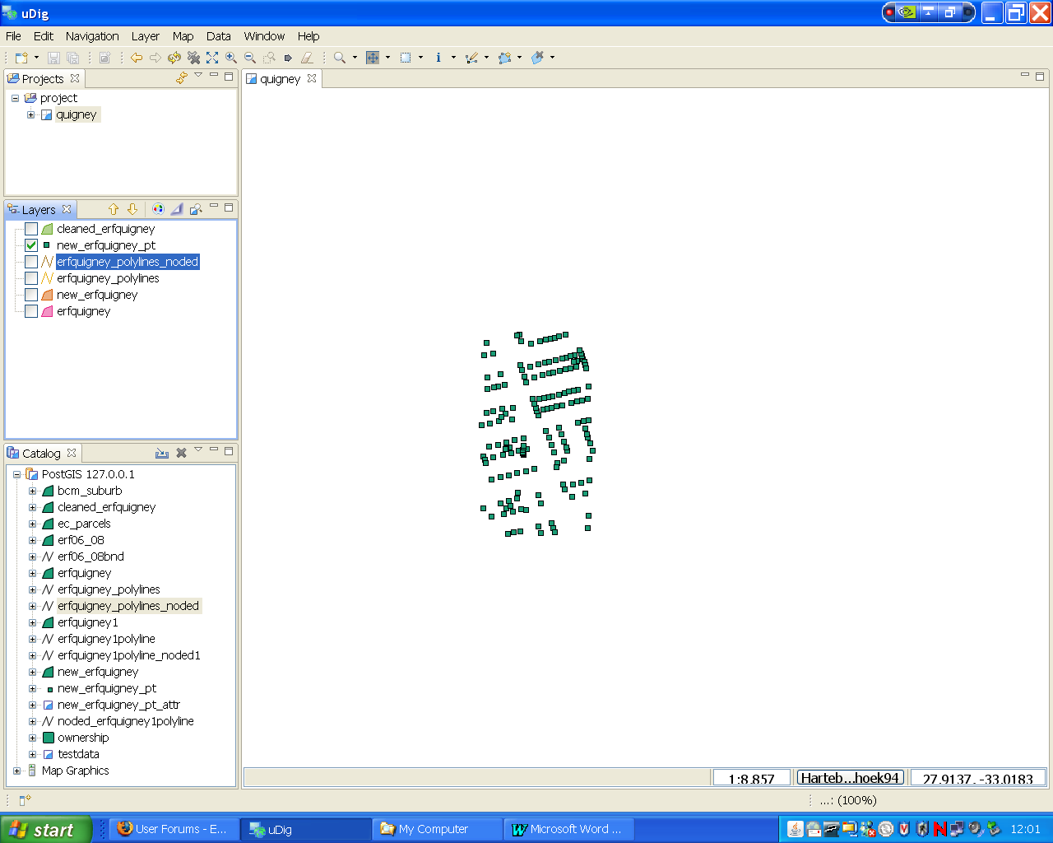
CREATE TABLE new_erfquigney_pt AS
SELECT id, ST_PointOnSurface
5
(the_geom) AS the_geom
FROM new_erfquigney;

Transfer attributes fron the original polygon into the point and create a table by using this statement

CREATE TABLE new_erfquigney_pt_attr AS
SELECT a.id, b."26digitkey", b."21digitkey", b.parceltype, b.parcel_num
FROM new_erfquigney_pt a
LEFT JOIN erfquigney b ON ST_Within(a.the_geom, b.the_geom);

Join the table above to the repolygonized feature

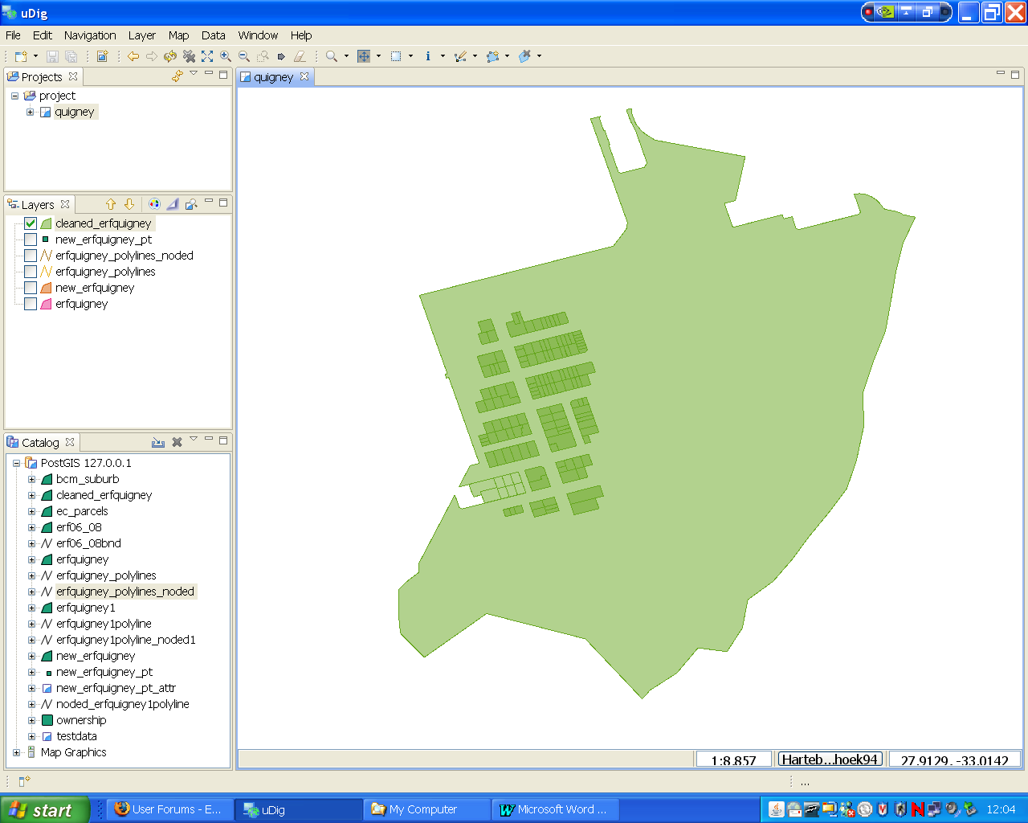
CREATE TABLE cleaned_erfquigney AS
SELECT *
6
FROM new_erfquigney a LEFT JOIN new_erfquigney_pt_attr b USING (id);

The resulting SMALL POLYGONS are composed of the original SMALL POLYGON and BIG POLYGON

HOW CAN I RECTIFY THIS?
I WOULD WANT AN OUTCOME LIKE 4 BUT WITH THE ATTRIBUTES FROM 1

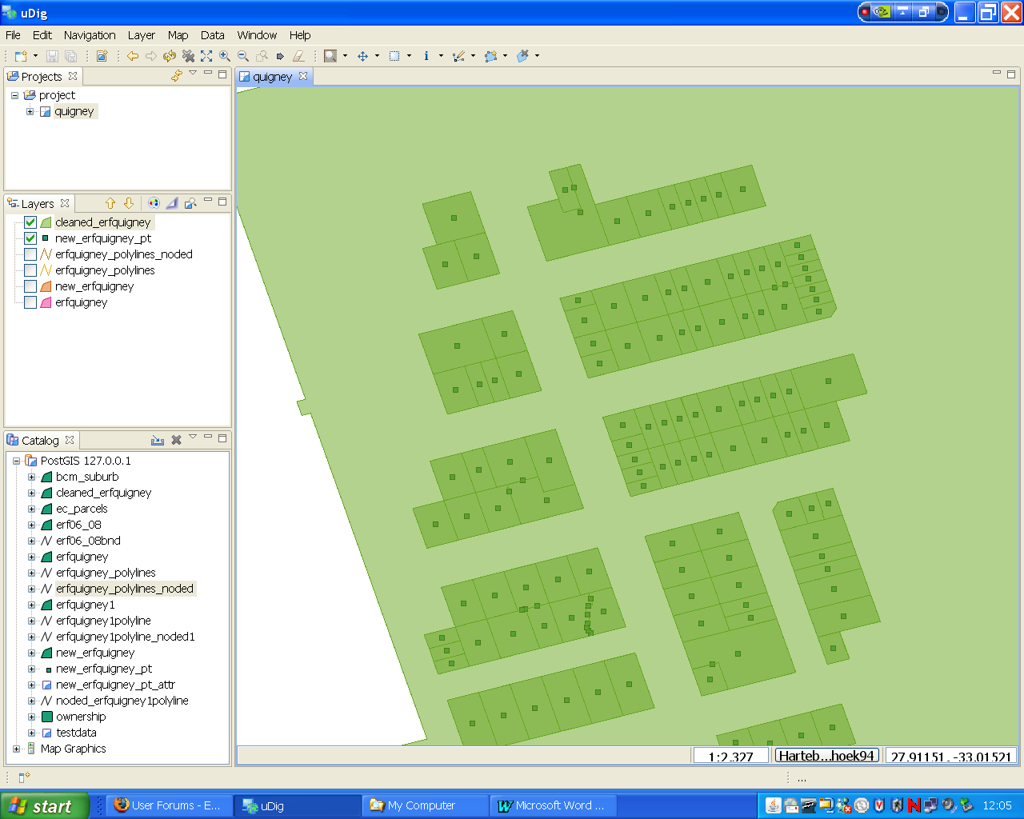
From this statement

CREATE TABLE new_erfquigney_pt AS
7
SELECT id, ST_PointOnSurface
(the_geom) AS the_geom
FROM new_erfquigney;

points are created where there are no polygons

WHAT IS THE CAUSE OF THIS?

