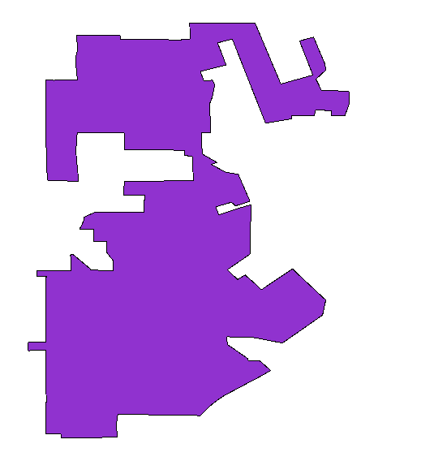⬅ This is how this city looks like
Below is the data for it:
astext
MULTIPOLYGON(((-90.00186 38.56423,-90.00143 38.56424,-90.00097 38.56417,-90.00028 38.56422,-89.99842 38.56425,-89.99813 38.56424,-89.99833 38.56631,-89.99832 38.56687,-89.99826 38.56719,-89.99816 38.56759,-89.99812 38.56792,-89.99812 38.56814,-89.99823 38.56951,-89.99754 38.56951,-89.99659 38.5695,-89.99556 38.56952,-89.99443 38.56949,-89.99342 38.56951,-89.99304 38.5695,-89.99303 38.56905,-89.99041 38.56904,-89.98759 38.569,-89.98578 38.56897,-89.9858 38.56909,-89.98476 38.56909,-89.98477 38.57101,-89.98418 38.57099,-89.98233 38.57099,-89.97938 38.57098,-89.97779 38.57097,-89.977 38.57095,-89.97395 38.56374,-89.97014 38.5648,-89.97173 38.56886,-89.97005 38.56931,-89.96948 38.56793,-89.96889 38.56654,-89.96872 38.56615,-89.9686 38.5654,-89.96977 38.56432,-89.96913 38.563,-89.96587 38.56287,-89.96585 38.56134,-89.96633 38.55999,-89.96793 38.56,-89.96791 38.56056,-89.9698 38.56067,-89.96999 38.56001,-89.97067 38.56001,-89.97263 38.56,-89.97264 38.55961,-89.97578 38.55909,-89.97592 38.55948,-89.97804 38.56483,-89.97972 38.56908,-89.98148 38.56862,-89.98117 38.56786,-89.98046 38.56601,-89.98352 38.56522,-89.98309 38.5641,-89.98209 38.56419,-89.9818 38.56363,-89.98207 38.56232,-89.98218 38.56195,-89.98241 38.56139,-89.98228 38.55791,-89.98341 38.55792,-89.98329 38.55542,-89.98154 38.55443,-89.98222 38.5542,-89.98056 38.55328,-89.979 38.55301,-89.97894 38.55285,-89.97843 38.55168,-89.97762 38.54981,-89.97934 38.54926,-89.97964 38.54956,-89.9799 38.54967,-89.9817 38.54915,-89.98132 38.5482,-89.97892 38.549,-89.97764 38.54935,-89.97756 38.54936,-89.97749 38.54937,-89.9775 38.54892,-89.97753 38.54783,-89.97755 38.54633,-89.97759 38.54369,-89.97762 38.54355,-89.97771 38.54346,-89.97914 38.54248,-89.98031 38.54167,-89.97909 38.54052,-89.9782 38.54106,-89.97711 38.5401,-89.97653 38.53953,-89.97628 38.53929,-89.97543 38.53986,-89.97461 38.54041,-89.97256 38.54179,-89.97226 38.54148,-89.96861 38.53807,-89.96899 38.53629,-89.97376 38.53297,-89.977 38.53359,-89.97768 38.53368,-89.97809 38.5337,-89.98035 38.53371,-89.98032 38.53281,-89.97789 38.53113,-89.97781 38.53084,-89.97644 38.53084,-89.97517 38.52972,-89.97519 38.52969,-89.9765 38.52895,-89.98021 38.52698,-89.98083 38.52663,-89.98128 38.52634,-89.98218 38.52565,-89.9828 38.52509,-89.98355 38.52432,-89.98413 38.52438,-89.98551 38.5244,-89.98687 38.5244,-89.98725 38.5244,-89.98837 38.52444,-89.98907 38.52444,-89.99333 38.52452,-89.99353 38.52311,-89.99335 38.52179,-89.99777 38.5217,-90.00009 38.52167,-90.00009 38.52216,-90.00184 38.52216,-90.00184 38.52332,-90.00184 38.52483,-90.00183 38.52633,-90.00185 38.52987,-90.00184 38.53,-90.00185 38.53035,-90.00185 38.53082,-90.00184 38.53138,-90.00185 38.53178,-90.00185 38.53197,-90.00186 38.53214,-90.00398 38.53206,-90.00398 38.53304,-90.00293 38.5331,-90.00185 38.53312,-90.00185 38.53416,-90.00186 38.53464,-90.00185 38.53665,-90.00185 38.53746,-90.00185 38.5379,-90.00185 38.53891,-90.00185 38.54008,-90.00183 38.54089,-90.00298 38.54089,-90.00297 38.54153,-90.00183 38.54154,-90.00061 38.54155,-89.99887 38.54154,-89.99885 38.54181,-89.99889 38.54266,-89.99893 38.54322,-89.99896 38.54328,-89.99901 38.54334,-89.99874 38.54356,-89.997 38.54212,-89.99669 38.54185,-89.99653 38.54167,-89.99617 38.54169,-89.996 38.54169,-89.99556 38.54159,-89.99535 38.54157,-89.99384 38.54156,-89.99385 38.54272,-89.99464 38.54372,-89.99461 38.54501,-89.99617 38.545,-89.99615 38.54649,-89.99789 38.54652,-89.99762 38.54694,-89.99743 38.54741,-89.99734 38.5477,-89.9973 38.54795,-89.99596 38.54854,-89.99023 38.54854,-89.99014 38.55054,-89.99263 38.55054,-89.99255 38.55222,-89.99043 38.55219,-89.98432 38.55226,-89.98436 38.5528,-89.98448 38.55513,-89.98543 38.55527,-89.98541 38.5554,-89.98544 38.55564,-89.98543 38.55571,-89.98538 38.55584,-89.98717 38.5559,-89.99028 38.55595,-89.99117 38.55597,-89.99251 38.55595,-89.99254 38.55791,-89.99815 38.55797,-89.99829 38.55596,-89.99829 38.55554,-89.99815 38.55394,-89.99804 38.55281,-89.998 38.55216,-90.00171 38.55232,-90.00182 38.5559,-90.00184 38.55639,-90.00187 38.55801,-90.0019 38.56007,-90.00184 38.5629,-90.00186 38.56423)))

