GDAL 1.9 problem

The files uploaded in the database PostGIS 2.0:
056n05_0100_demw.tif | 056n05_0100_deme.tif
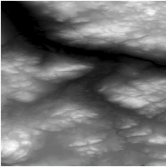 | 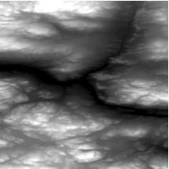

The result obtained with the command:
"C:\Program Files\GDAL\gdal_translate" -a_nodata "-32767" -of GTIFF "PG:host=myhost port=14070 dbname='myDB' user='myuser' password='mypassword' schema='dbelange' table='elevationTest' mode=2 where=\"filename LIKE \'%056n05%\'\" " 056N05_testGDAL1.9.tif

With GDAL 1.8 (result expected):
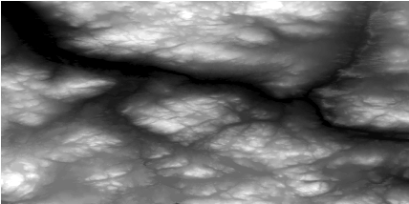

With GDAL 1.9 (bad result):
