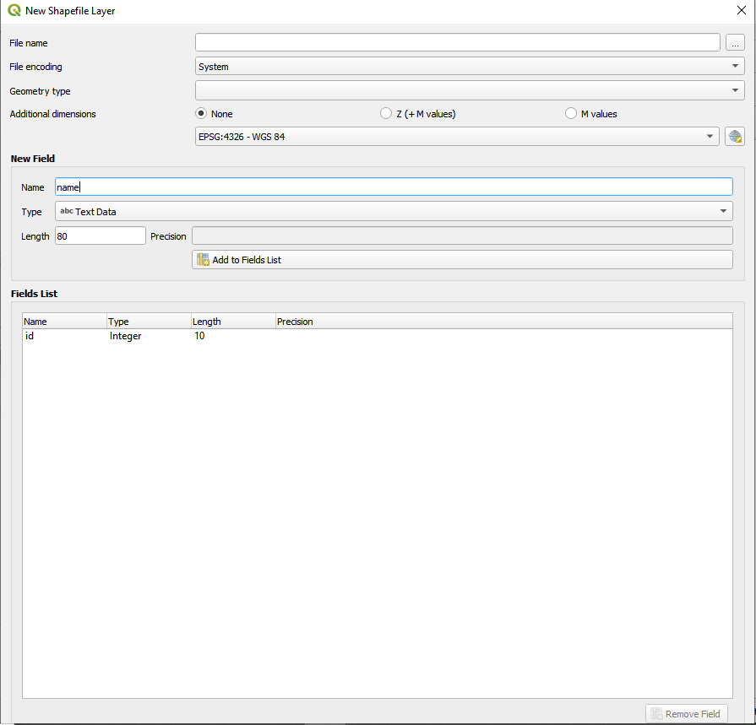
Note: I can not see OK since I can not move the page further down

